Buret

A buret is used to deliver solution in precisely-measured, variable volumes. Burets are used primarily for titration, to deliver one reactant until the precise end point of the reaction is reached.

Using a Buret

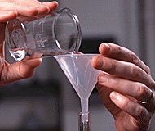 |  | To fill a buret, close the stopcock at the bottom and use a funnel. You may need to lift up on the funnel slightly, to allow the solution to flow in freely.
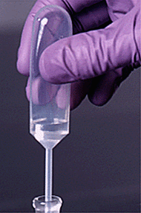 |  | You can also fill a buret using a disposable transfer pipet. This works better than a funnel for the small, 10 mL burets. Be sure the transfer pipet is dry or conditioned with the titrant, so the concentration of solution will not be changed.  Before titrating, condition the buret with titrant solution and check that the buret is flowing freely. To condition a piece of glassware, rinse it so that all surfaces are coated with solution, then drain. Conditioning two or three times will insure that the concentration of titrant is not changed by a stray drop of water.
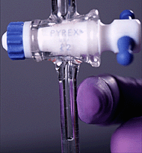 |  | Check the tip of the buret for an air bubble. To remove an air bubble, whack the side of the buret tip while solution is flowing. If an air bubble is present during a titration, volume readings may be in error.
Rinse the tip of the buret with water from a wash bottle and dry it carefully. After a minute, check for solution on the tip to see if your buret is leaking. The tip should be clean and dry before you take an initial volume reading.

When your buret is conditioned and filled, with no air bubbles or leaks, take an initial volume reading. A buret reading card with a black rectangle can help you to take a more accurate reading. Read the bottom of the meniscus. Be sure your eye is at the level of meniscus, not above or below. Reading from an angle, rather than straight on, results in a parallax error.

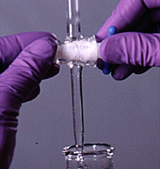 |  | Deliver solution to the titration flask by turning the stopcock. The solution should be delivered quickly until a couple of mL from the endpoint.
The endpoint should be approached slowly, a drop at a time. Use a wash bottle to rinse the tip of the buret and the sides of the flask. Your TA can show you how to deliver a partial drop of solution, when near the endpoint.

For more information, see the techniques page ontitration.

Trustees of Dartmouth College, Copyright 1997–2000
http://www.dartmouth.edu/~chemlab/techniques/buret.html
- What is a A buret is used for?____________________________________________________________________________
- What do you need to allow the solution to flow in freely? ____________________________________________
- How can also fill a buret?________________________________________________________________________________
- How can you condition a piece of glassware?__________________________________________________________
- What can help you to take a more accurate reading on your buret?_________________________________

